USB2.0转RS232串口线PL2303RA/PL2303HXD芯片安装驱动使用说明书
USB2.0 convert RS232 Serial
PL2303RA/PL2303HXD Chip installation drive instruction
欢迎使用本公司高品质串口线,此说明适用于 Welcome to use our company's high quality serial port, this description applies to DT-5001A,DT-5002A,DT-5003A,DT-5002B,DT-5002C,DT-5002D,DT-5002E,DT-5002F,DT-5002S,DT-5105,DT-5110,DT-5102B,DT-5302B,DT-5046.

安装驱动步骤的方法介绍
Ⅰ. Introduction to the installation of drive steps

使用产品光盘安装驱动
- use the product disc to install and drive
第一步：以DT-5002A为例，插入驱动光盘，打开光盘，
点击“windows”文件夹开始安装驱动(以下说明都是在win7系统操作的)，如图：
Step one: Take DT-5002A as an example, insert drive CD, then open CD, click on the "windows" folder to install the driver (the following instructions are all operated on the win7 system):

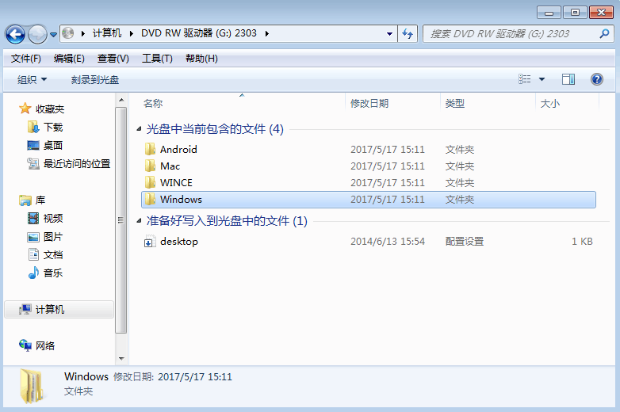
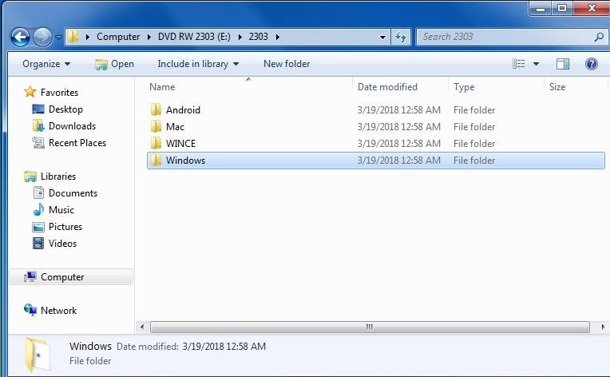

第二步：点击“windows”后会出现两个压缩包，win7以上版本选择“PL2303-Prolific-DriverInstaller-v1180”压缩包，并解压。
Step two: After clicking "windows", there will be two compressed packets. The win7 version will choose the "PL2303-Prolific-DriverInstaller-v1180" compression pack and decompress it.
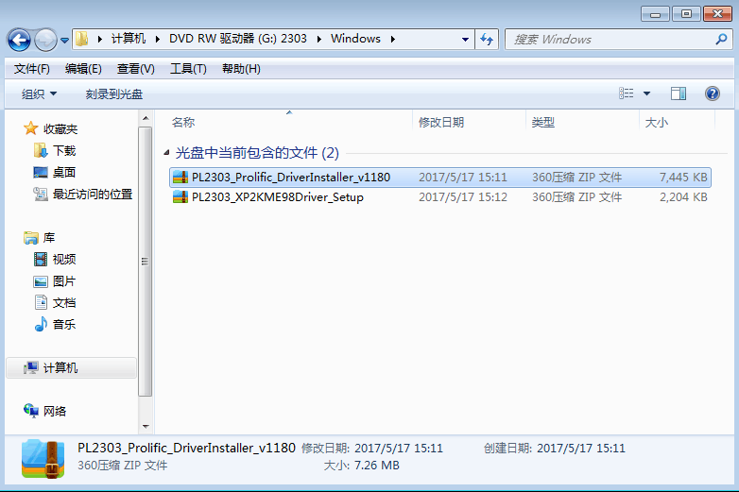
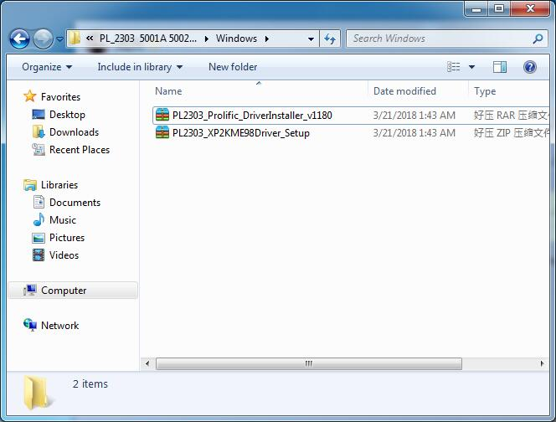

第三步：解压后如下图所示，双击应用程序窗口。
Step three: After decompression, double click the application window as shown below.
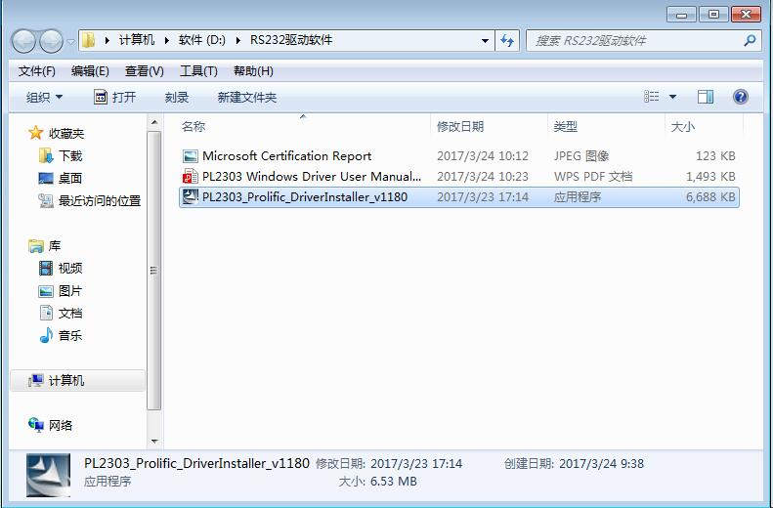
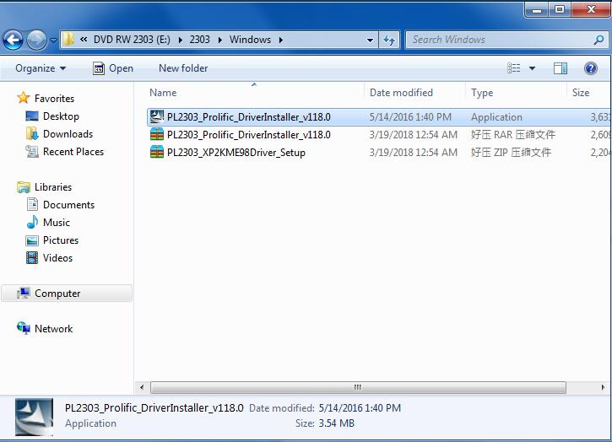
第四步：双击运行程序，会弹出安装对话框，点击“下一步”，如下图所示。
Step four: Double click the running program, you will pop up the installation dialog box, click next, as shown below.
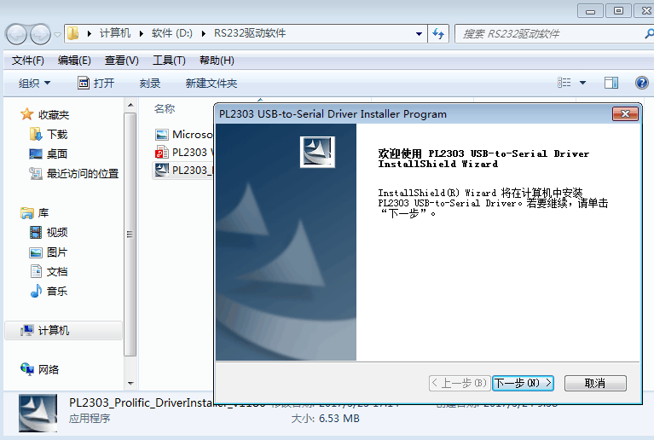
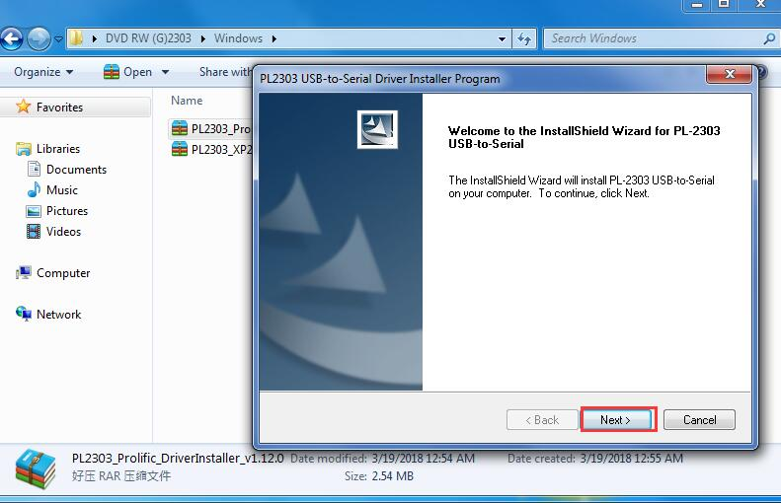
第五步：点击“下一步”后，系统将会自动完成安装的过程，等安装过程结束后点击对话框中的“完成”结束安装过程，如图：
Step five: After clicking on "next step", the system will automatically complete the process of installation, and after the end of the installation process, click the "complete" in the dialog box to end the installation process:
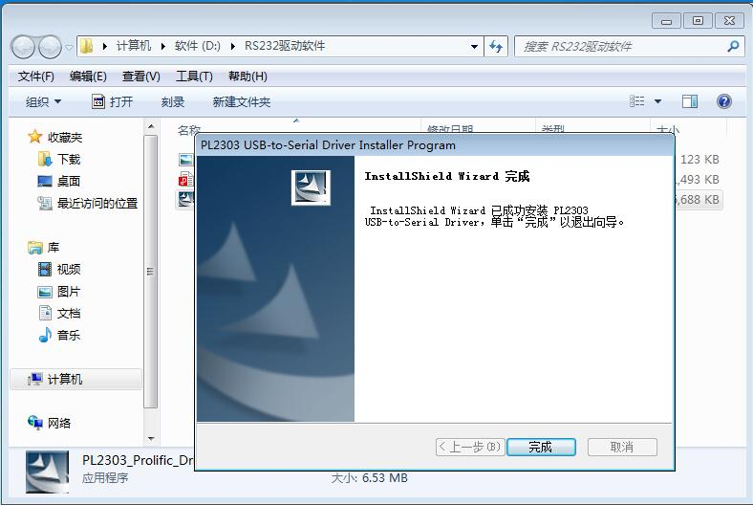
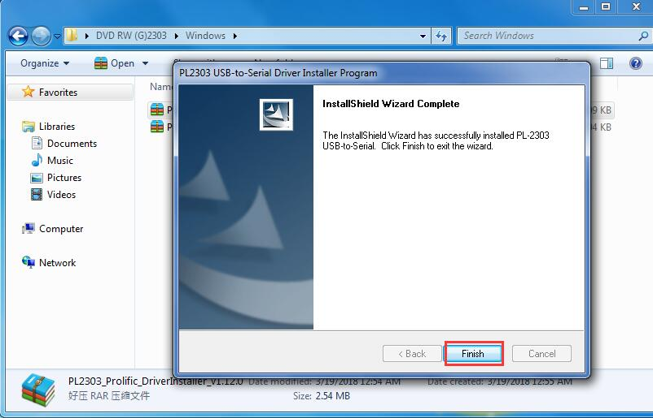

设备管理器中设置端口号
Ⅱ. Setting up port number in Device Manager

第一步：右击“计算机”，选择“管理”,如图：
Step one: Right click on the computer and choose "management".

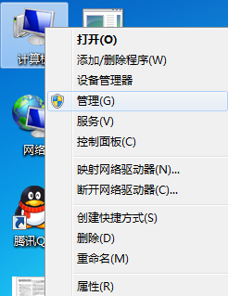
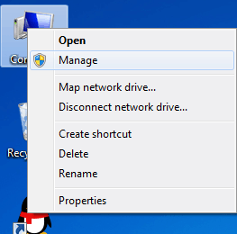
第二步：将串口线DT-5002A插入到电脑USB接口上，在“管理”中选择“设备管理器”，在“设备管理器”中，“端口”这一项可以查看到串口线DT-5002A已安装好驱动，并弹出“COM”口如图：
Step two: Insert the serial port line DT-5002A into the computer USB interface, select "device manager" in "management", in "device manager", "port" this item can see that the serial port line DT-5002A has been installed, and pops "COM".

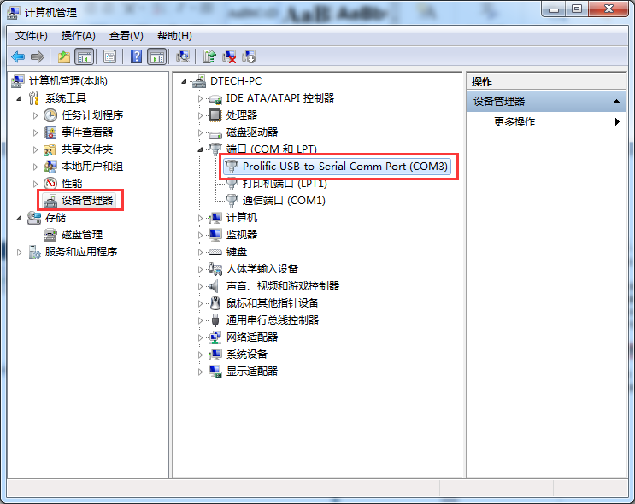
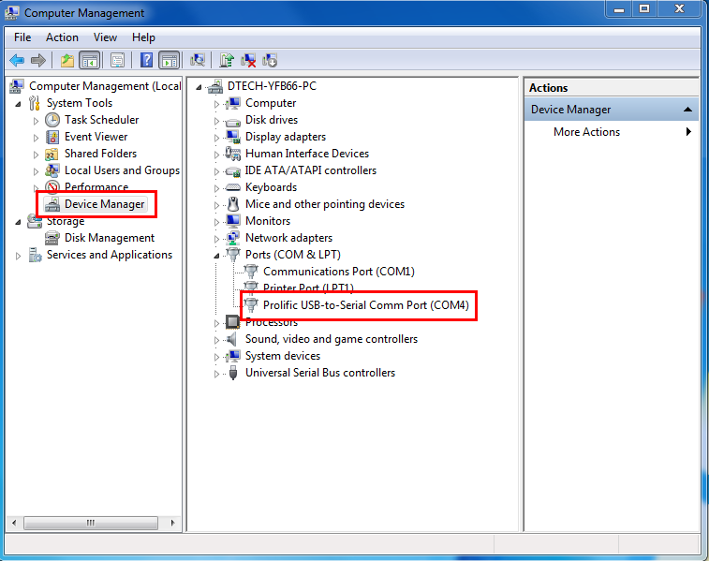
若插入串口线后在“设备管理器“中查看不到该驱动，而是显示“unknown Device”，则更换电脑另外USB口测试，若还是出现这种情况，则有可能是串口线出现故障，建议退厂更换。如图：
If you insert the serial port line in the "device manager", not to see the driver, but to display "unknown Device", then replace the computer and USB test, if this is the case, it may be a serial line failure, it is recommended to return to the factory to replace. Figure:

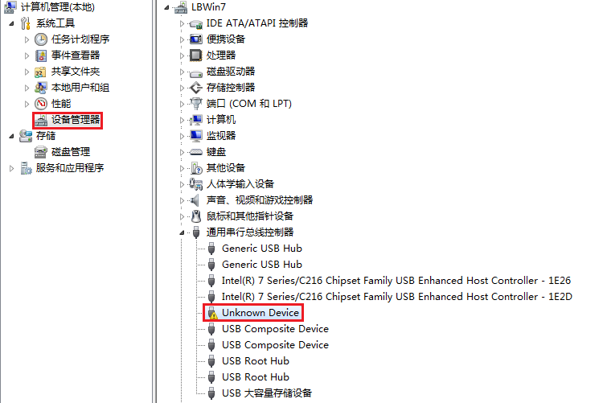
第三步：看到设备管理器设识别出COM口号，可能会无法与通讯设备连接，下图是某款LED显示屏的应用软件，可在软件中设置端口更改COM口号，与设备管理器中的COM口一致，如图：
Step three: See the device manager set to identify the COM slogan, may not be able to connect with the communication device, the next figure is a LED display application software, the software can set the port change COM slogan, the same as device manager of the COM port:

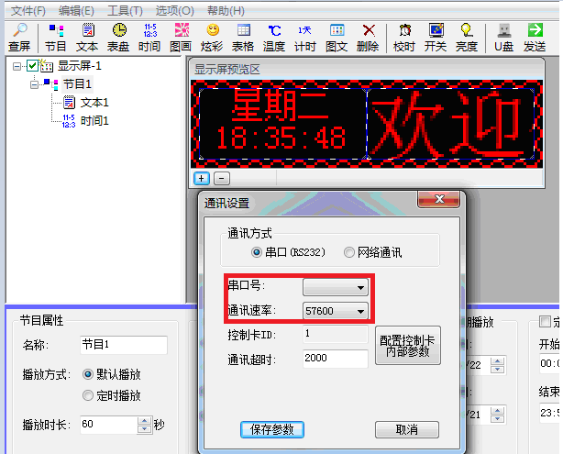
第四步：若软件中没有更多的COM口可供选择，或者选择的COM口还是无法连接，这时需要在设备管理器中更改COM号，右击图中“COM”口，选择属性，如图：
Step four: If there are no more COM ports in the software, or the selected COM port is still unable to connect, then you need to change the COM number in the device manager, right click the "COM" port in the map, and select the attributes, such as the figure:

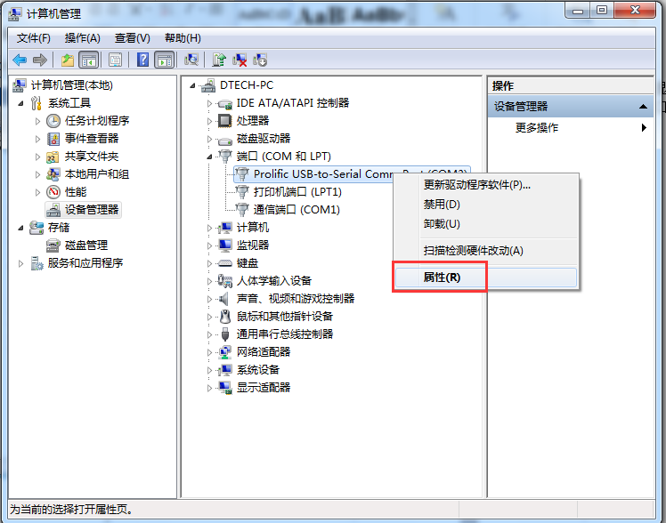
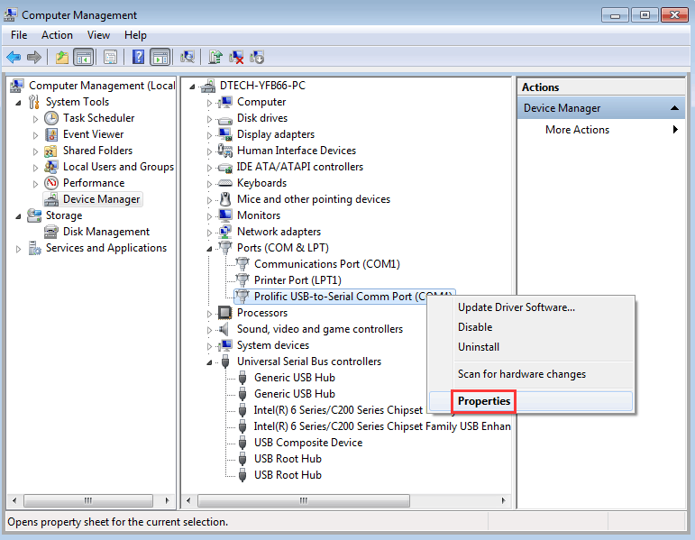

点击“属性”后，首先弹出来的是常规一栏，设备的状态显示“这个设备运转正常”说明驱动安装没有出现问题，然后点击“端口设置”，如图：
After clicking "attribute", the first shot is a regular column. The status of the device shows "this device is working properly". The driver installation does not appear to be a problem, and then click "port settings", such as:

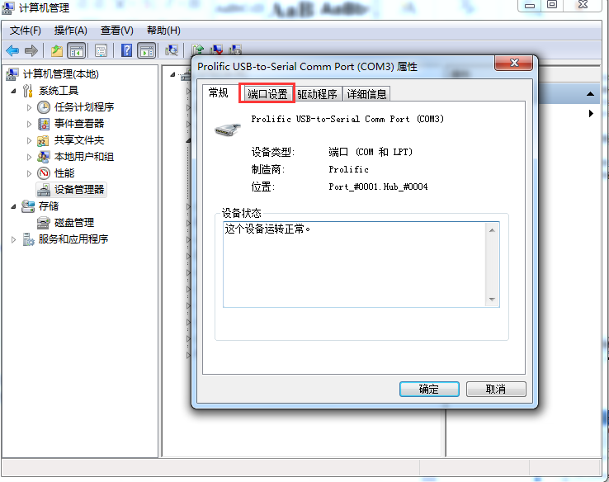
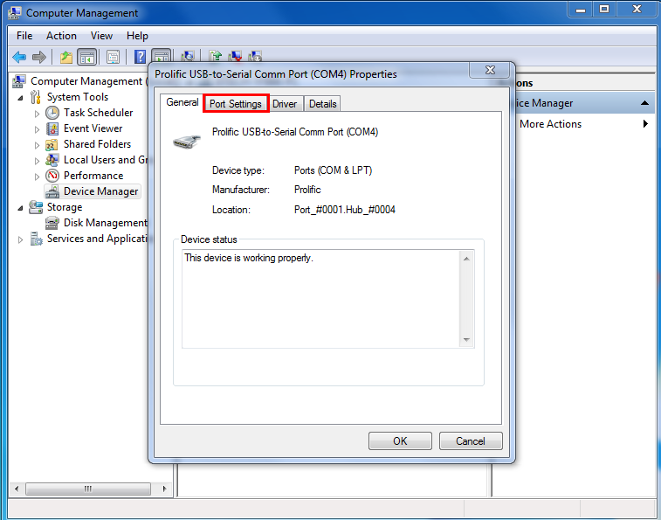
点击“端口设置”后，“位/秒”就是波特率的参数设置，如需更改可在此为串口线DT-5002A的波特率进行更改，之后点击“确定”如图：
After clicking "port settings", "bit / second" is the parameter setting of the baud rate. If you need to change, you can change it for the baud rate of the serial line DT-5002A, and then click "confirm":

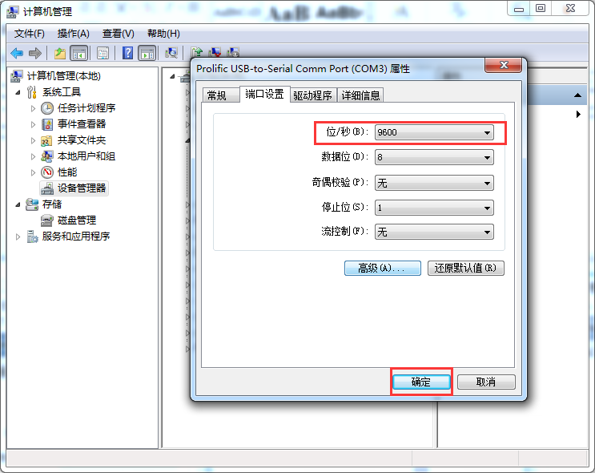
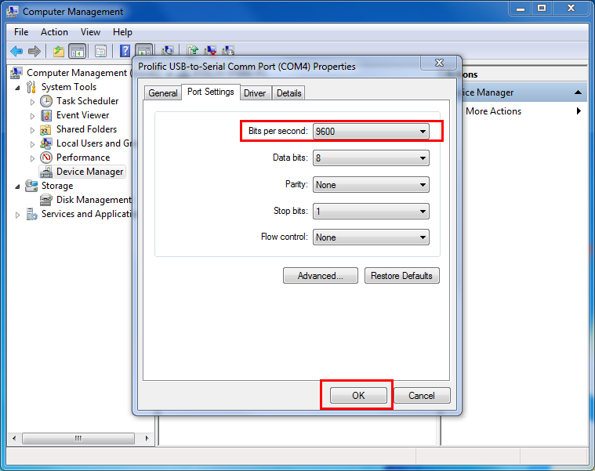
若用户还需要更改串口线DT-5002A端口，则需点击“端口设置”中的“高级设置”，如图：
If the user still needs to change the DT-5002A port of the serial port, then click "advanced settings" in the port settings:
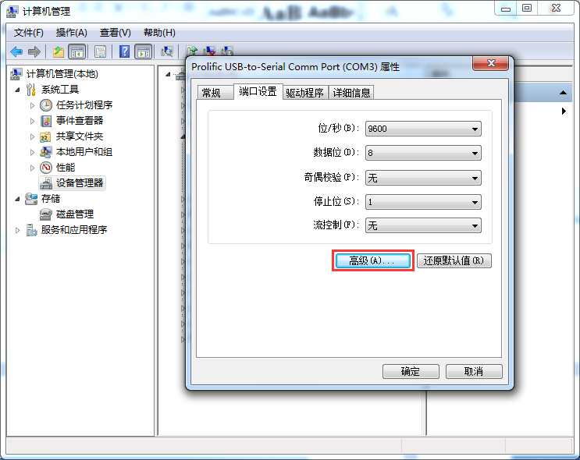
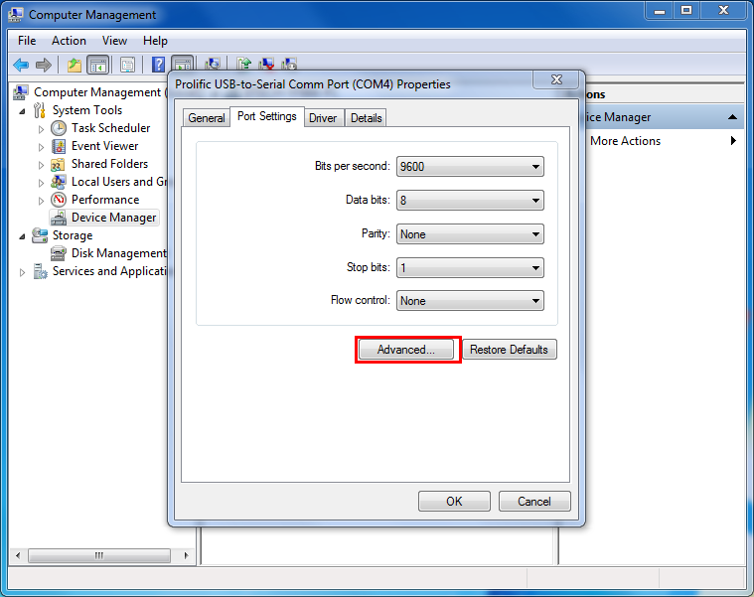
在“高级设置”中可以看到“COM端口号”设置，点击“COM端口号”选项可改变串口线的端口号，如图：
In the "advanced settings", you can see the "COM port" setting. Click the "COM port number" option to change the port number of the serial port:

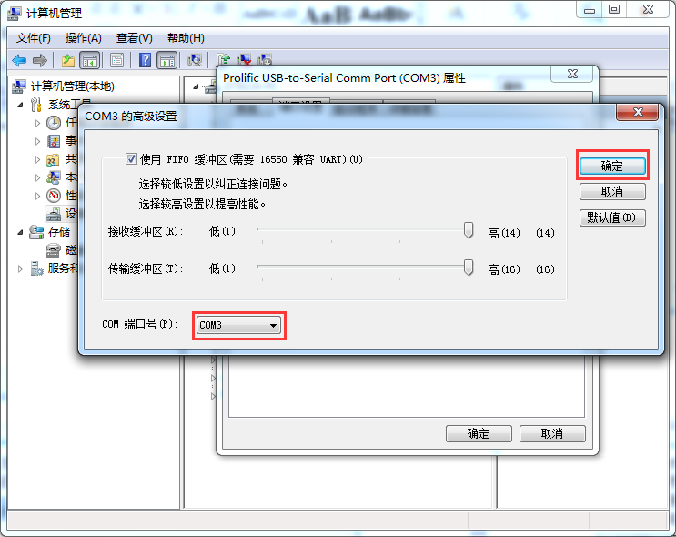
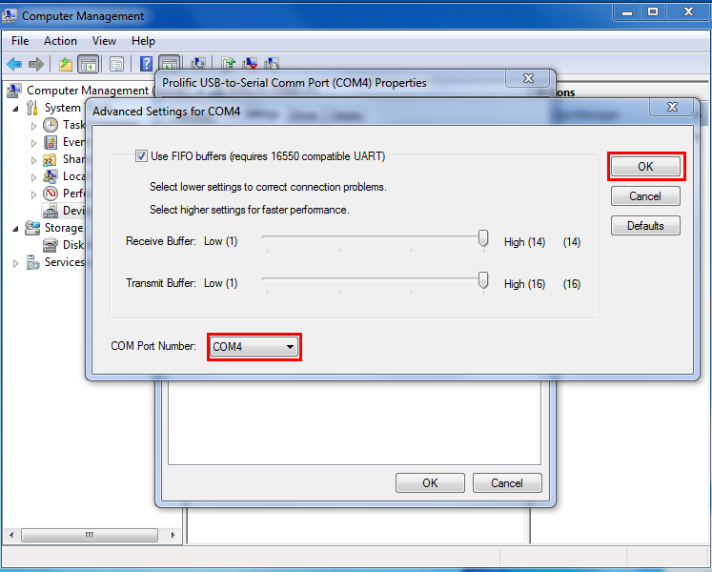
设定完串口线的端口号之后，则可退回“设备管理器”中查看串口线是否已经更改端口号，若端口号仍无更改，则可点击“设备管理器”中右上角的更新驱动程序图标进行更新（一般win7系统设置完后会自动更新端口号，xp系统则需要通过更新驱动程序才可看到端口号是否变更），如图：点击扫描键
After setting the port number of the serial port line, you can return to the "device manager" to see if the port line has changed the port number. If the port number is still unchanged, you can click the update driver Icon in the upper right corner of the "device manager" to update the port number (the general win7 system will automatically update the port number, XP system after the system is set up. " You need to update the driver to see if the port number is changed. For example, click Scan key:
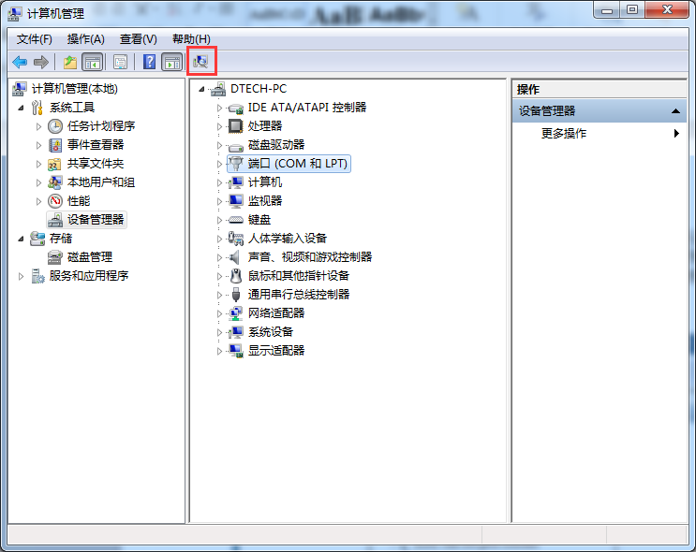
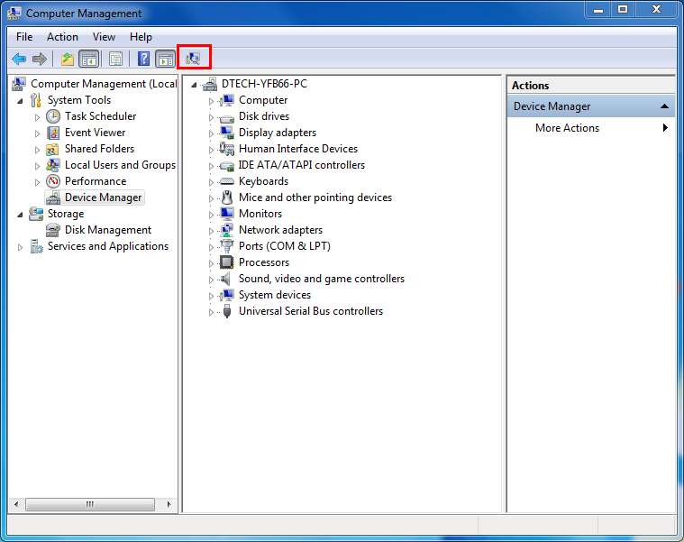
到此已介绍完串口线的安装，使用全过程。如串口线出现安装故障，或在COM口前有“惊叹号”，可在其他电脑进行测试，如出现同样现象，则建议退厂维修。在使用过程出现通讯问题请检查的您的插接件是否接触良好，端口号是否错误，波特率是否已被更改等情况；也可以让设备关掉电源重新启动，或者让设备去识别串口线等等办法来排除故障，但也不排除兼容性问题。
The installation of serial port has been introduced, and the whole process has been used. If there is an installation fault on the serial cable or an exclamation mark before the COM port, it can be tested on other computers. If the same phenomenon occurs, it is recommended that the factory be repaired. In the use of communication problems, please check if your inserts are in good contact, the port number is wrong, the baud rate has been changed, and the device can turn off the power reboot, or let the device identify the serial line and so on to exclude the fault, but it does not exclude the compatibility problem.

